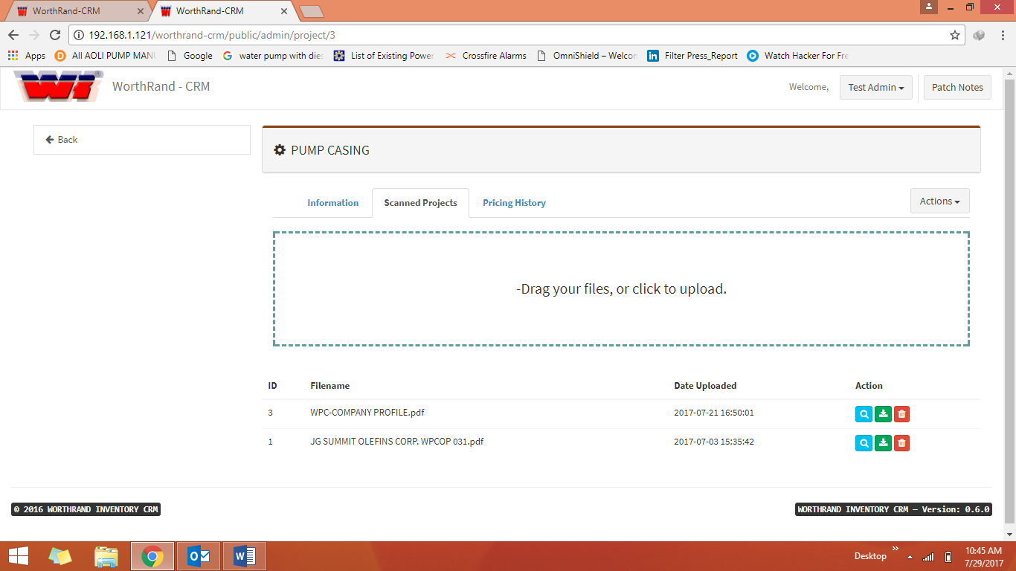**ADMIN ACCOUNT**

**PROJECT**

**SCANNED PROJECTS**

**\*The problem is we can’t view, download and deleting the upload files. It was debugging.**

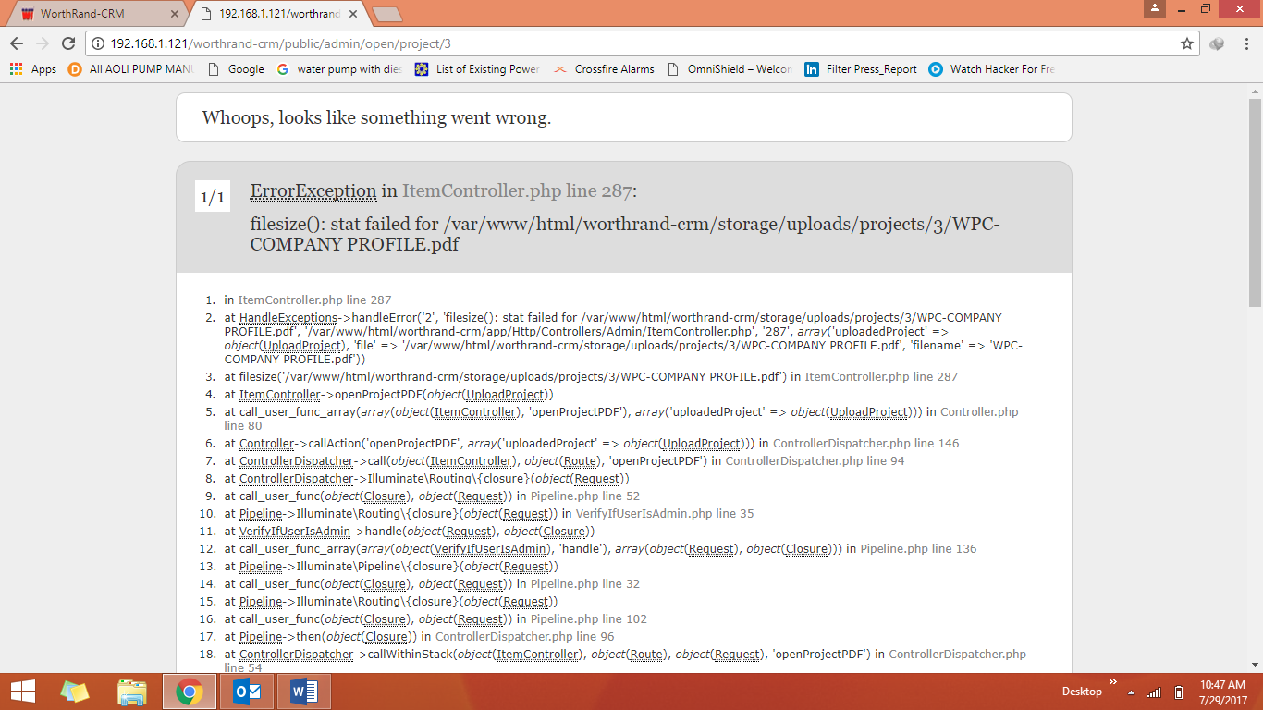

**ADMIN ACCOUNT**

* **Adding Pricing History (PROJECT). It was debugging.**

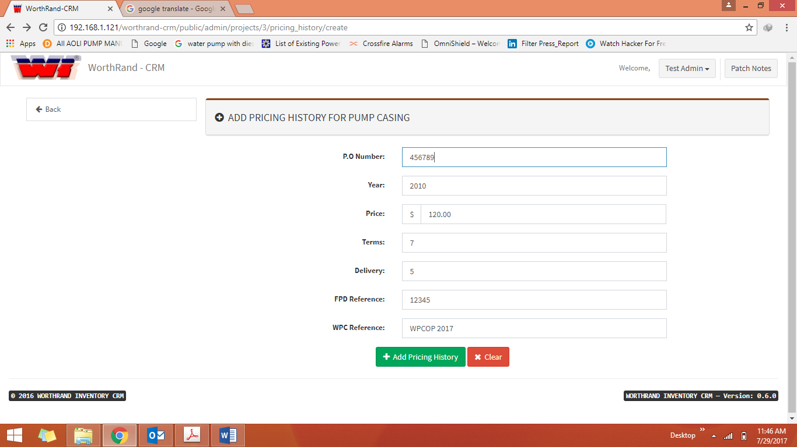

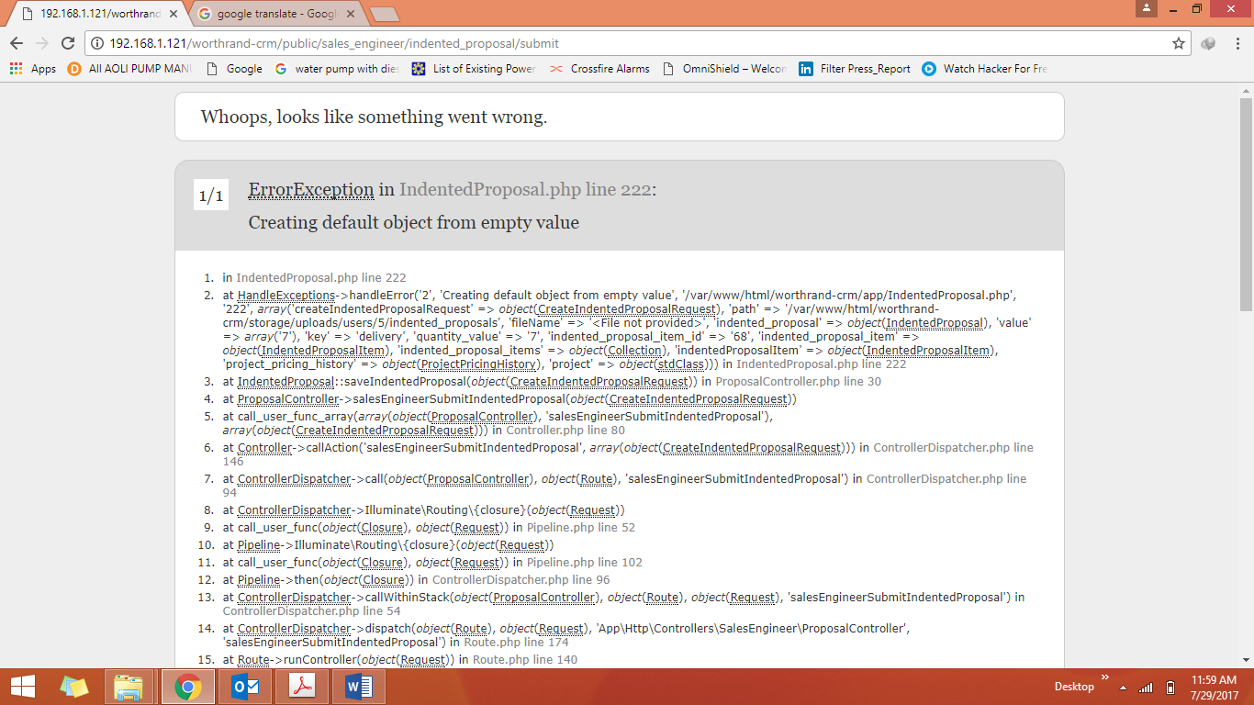

**Sales Engineer (SE) ACCOUNT**

* Remove this button, it’s only for **ADMIN ACCOUNT.**

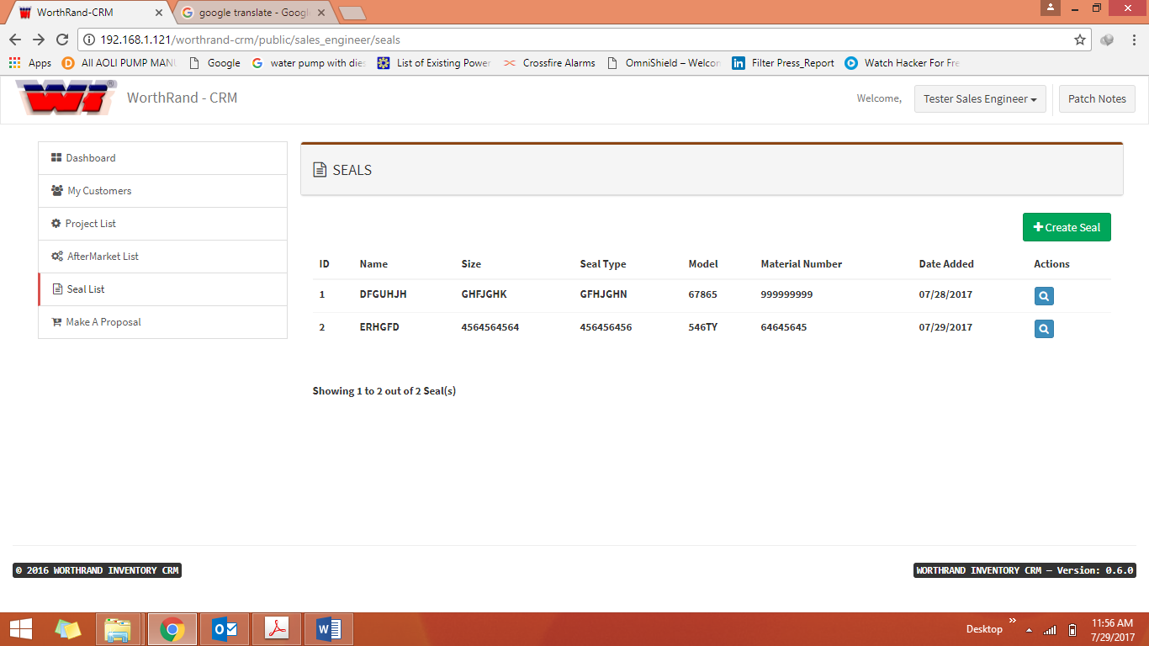

* We try to open other accounts, but only test accounts, [jgoliver@worthrand.com](mailto:jgoliver@worthrand.com) and [rkdgonzales@worthrand.com](mailto:rkdgonzales@worthrand.com) are working. And the others are not working.